**Acknowledgement**

*We would like to express our deepest and sincere appreciation for all expressions of love and kindness. You have made our sorrow a time of celebration and triumph. We are sure that God sent you into our lives to comfort us in the homegoing of our loved one. It is our prayer that God will continue to Bless each and every one of you.*

*~The Family of Cynthia Marie Grant*

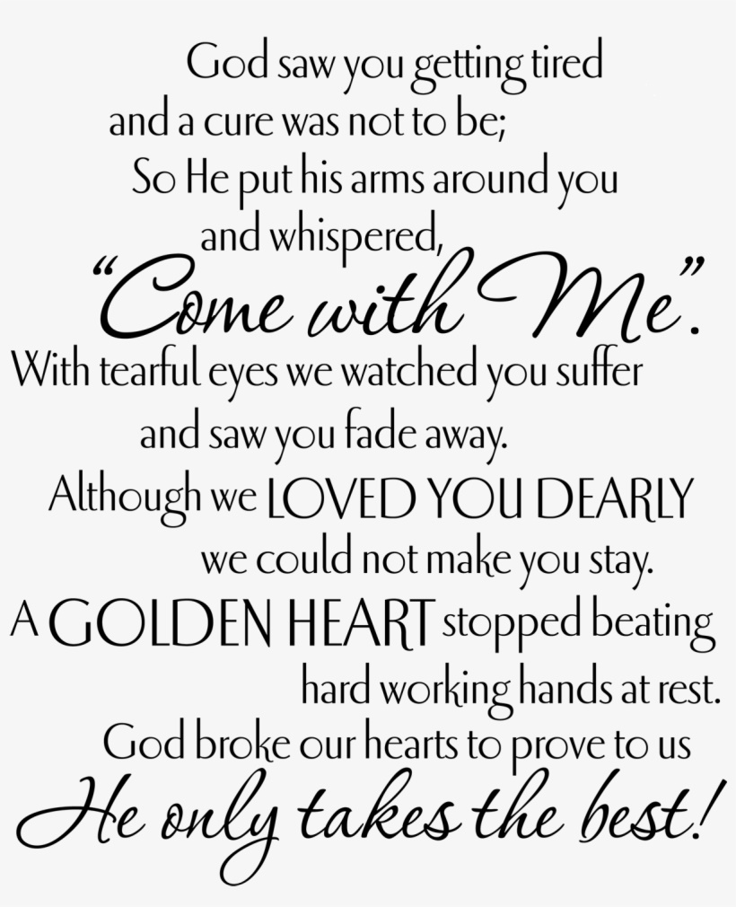

**

To offer condolences to The Grant Family,

visit [www.TheChapelofPeace.com](http://www.thechapelofpeace.com/)

**

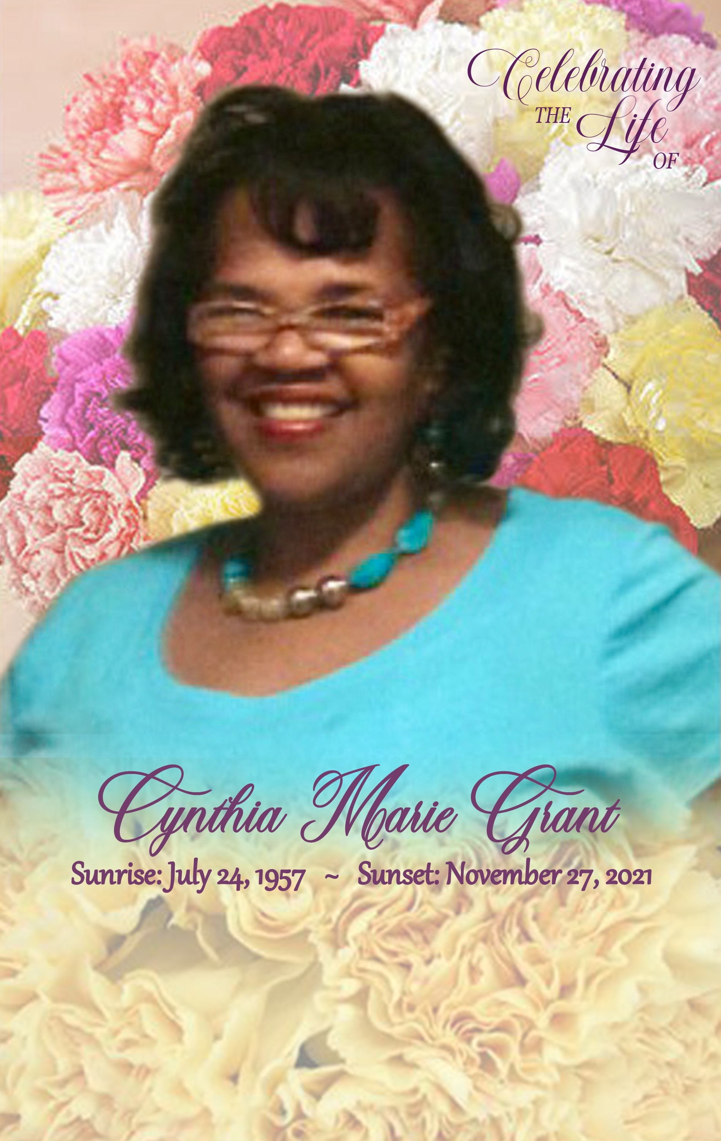

**~Service~**

**Saturday, December 4, 2021**

**Visitation 1:00pm - Memorial 2:00pm**

**MARLAN J. GARY FUNERAL HOME**

***Chapel of Peace East***

5456 Livingston Avenue

Columbus, Ohio 43232

**Apostle Ronald G. Hairston Sr., Officiating**

The Obituary

***Cynthia Marie Grant (Cindy***), age 64, Columbus. Ohio went home to be with the Lord at 6:38pm on Saturday, November 27, 2021, after a brief stay at OSU hospital.

***Cynthia*** was born on July 24, 1957, in Columbus, Ohio to Cassandra May Hairston and Harvey West, she was welcomed by her big brother Ronald and was the older sister to four younger siblings. Cynthia attended McGuffey Junior High School, graduated from Linden McKinley High School and later obtained her Bachelor’s degree from Wilberforce University.

***She*** became a young mother to her oldest son Kevin. She later married Pierre Grant and from their union Jamelle and Camille were born. Cindy loved working with and helping students. She spent her professional career in the college Financial Aid Offices of Columbus State, UNCW & North Carolina Central University.

***Cindy*** accepted the Lord early in life and served in many capacities in her church home. At the time of her transition, she was a faithful member of Kingdom Faith International Christian Center, where she faithfully served on the GEM ministry where she loved working with the children; prayer and hospitality teams; and dance team.

***Cynthia*** was passionate about her relationship with the Lord. To her friends, she was a sister in Christ, a confidant, a sounding board and offered an ear that listened. To her family she was our rock and affectionately known as “Sister Gracie” who always offered words of encouragement, a much needed scripture, a prayer and lots of love.

***Cynthia*** leaves to cherish her memory her siblings Ronald (Theresa), Adriene, Tina, Robert, Anthony (Ruth); her children Kevin, Jamelle (Angel), North Carolina: Camille, Stepsons Cortez and Rashad; grandchildren Keaira, Levi, Amya, Saniya, Melo, Makai; great grandson Asa and a host of nephews, nieces, family and friends.

***She*** was preceded in death by her loving and devoted mother Cassandra May Hairston and father Harvey West Sr.

***To*** God be the Glory for a life well lived!

[](http://www.google.com/imgres?imgurl=http://www.bridalassociationofamerica.com/clipart/bibles/bible_09.gif&imgrefurl=http://www.bridalassociationofamerica.com/clipart/bibles/&h=808&w=1464&sz=38&tbnid=eYif1lnRBQy7gM:&tbnh=83&tbnw=150&prev=/images?q=bible+clip+art&hl=en&usg=__JZosKl3Dpg31s0Mdg2M4-TBXltg=&ei=egCgSuygGt6PmAeWlNn3DQ&sa=X&oi=image_result&resnum=2&ct=i)

Order of Celebration

MUSICAL PRELUDE Chapel of Peace Music Ministry

PARTING VIEW Immediate Family

WELCOME & INVOCATION Apostle Ronald G. Hairston Sr.

MUSIC SELECTION Dawn Holeman

SCRIPTURE READING

Old Testament Deacon Everett Archie

New Testament Deacon Chad King Sr.

PRAYER OF COMFORT Willa Brown

ACKNOWLEDGEMENTS/CONDOLENCES Shantel King

REMARKS Pastor Theresa Hairston

Anthony Hairston

Michael Hairston Shyresa King

Jamelle Grant

READING OF OBITUARY Keisha Jackson

MUSICAL SELECTION Dawn Holeman

The Eulogy

APOSTLE RONALD G. HAIRSTON, SR.

BENEDICTION Apostle Ronald G. Hairston, Sr.

RECESSIONAL “We’re Blessed/Shout Unto God

*“Well done. Thou good and faithful servant: thou has been faithful*

*over a few things, I will make thee ruler over many things: enter*

*thou into the joy of thy Lord”*

*Matthew 25:21 KJV*