Acknowledgement

*The Malone Family would like to thank you for your support and love for the family in this time during the loss of our mother. Your calls, concerns, food, and especially your prayers have not gone unnoticed. May God continue to bless each and every one of you.*

Pallbearers

*ANTONIO MALONE ~ JARRETT MALONE ~ JULIN MALONE*

*HERMAN MALONE ~ ROMELLO MALONE ~ JALAN MALONE*

Honorary Pallbearers

*MIKE SMITH ~ JUAN MALONE ~ RICHARD MALONE*

*HERMAN MALONE ~ JERRY BOYKINS ~ JIMMY PARKS*

Flowerbearers

*LADIES OF THE MALONE FAMILY*

***The Broken Chain***

*We little knew that morning*

*That God would call your name*

*In life we loved you dearly*

*In death we do the same*

*It broke our hearts to lose you*

*You did not go alone*

*For part of us went with you*

*The day God called you home*

*You left us beautiful memories*

*Your love is still our guide*

*And although we cannot see you*

*Your always by our side*

*Our family chain is broken*

*And nothing seems the same*

*But as God calls us one by one*

*The chain will link again*

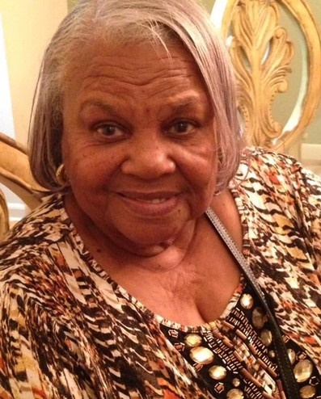

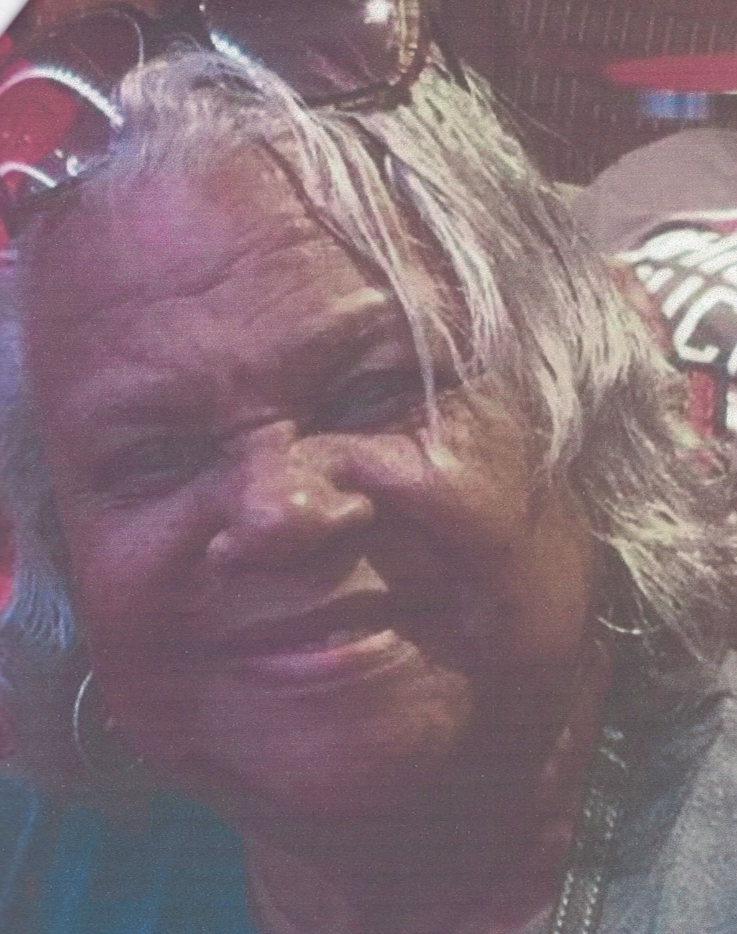

To offer condolences to The Malone Family,

visit [www.TheChapelofPeace.com](http://www.thechapelofpeace.com/)

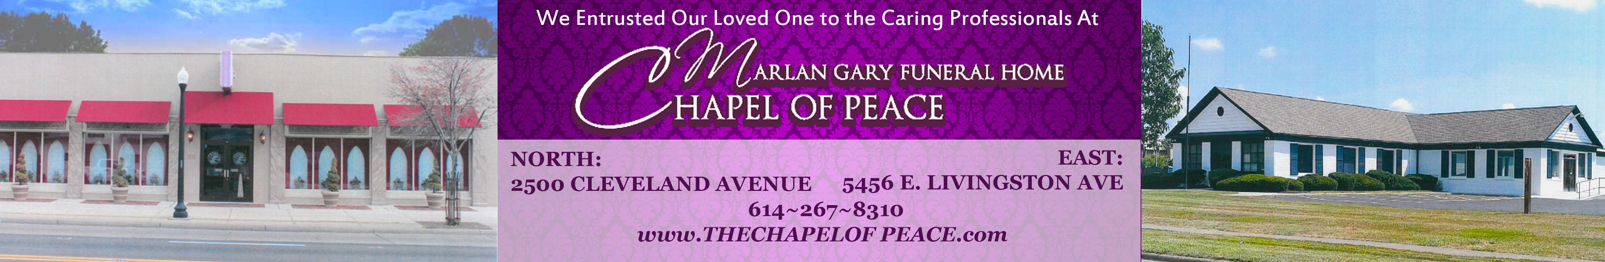

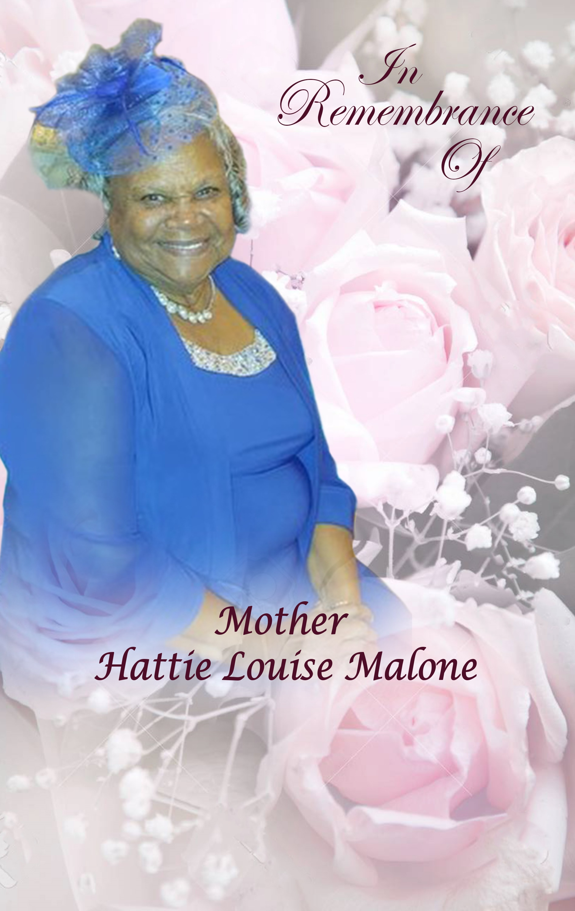

**MAY 22, 1941 ~ NOVEMBER 14, 2020**

**~Service~**

**TUESDAY, NOVEMBER 24, 2020 ~ 12:00 PM**

***Yeshua is Lord Ministries***

116 Miami Avenue

Columbus, Ohio

BISHOP WILLIAMS

*Officiating & Eulogizing Minister*

The Obituary

Hattie Louise Malone was called home to be with her Lord and Savior on November 14, 2020. Hattie was born to the union of Robert and Dilsie Malone on May 22, 1941 in Gray, Georgia. Hattie was a loving devoted single mother of 5 beautiful children and as well raised 2 grandchildren.

Hattie was raised in FlyTown, attended Columbus Public Schools, and graduated from Cosmetologist school in June of 1974. Hattie served as a Licensed Cosmetologist in the North Linden area for over 35 years. She retired from Beauty All Over in 2006. Hattie enjoyed spending time with her family and going to church, traveling, shopping and caring for others. Hattie willingly took care of her niece Diane and daughter in law Teresa, while they were battling cancer.

Ms. Malone was and will continue to be a mother figure to many in her community. Hattie was a faithful member of Shady Grove Baptist Church now known as Yeshuah is Lord Ministries for over 50 years where she was known as “Mother Hattie or Mother Malone”. Hattie performed many duties and wore many hats within her walk with Christ.

Hattie is preceded in death by her father and mother Robert Sr. and Dilsie Malone; brothers, Alex and Willie Malone and sisters Barbara Ann Malone and Mary Ferguson.

Hattie leaves to cherish her memory, her children, Herman (Harriett,) Donna) Ray ( Johnette), Richard (Karen) and Terry; grandchildren, Tomunisha, Antonio ( Monick), Hermon (Ashley) Sharay, Kourtney, Lauren, Romello, Franco and Jarrett Malone and  13 great grandchildren and 1 great- great  granddaughter; Hattie also leaves behind 2 brothers, Robert Jr. and Henry Malone; sister, Martha ( Billie) Williams and a truckload of nephews and nieces who are also special to her; and 2 bonus  special daughters, Renae Pryor and Darlene Matthews and a host of family members that are all special to her in their own special way and whom she loves more than mere word could never describe.

Hattie Louise Malone “Ms. Malone” took her last and final trip to be with her loved ones who have gone before and have been waiting for her arrival. Her smile and warm loving arms and comforting word will be greatly missed by all who loved and cherished her.

[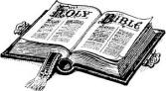](http://www.google.com/imgres?imgurl=http://www.bridalassociationofamerica.com/clipart/bibles/bible_09.gif&imgrefurl=http://www.bridalassociationofamerica.com/clipart/bibles/&h=808&w=1464&sz=38&tbnid=eYif1lnRBQy7gM:&tbnh=83&tbnw=150&prev=/images?q=bible+clip+art&hl=en&usg=__JZosKl3Dpg31s0Mdg2M4-TBXltg=&ei=egCgSuygGt6PmAeWlNn3DQ&sa=X&oi=image_result&resnum=2&ct=i)

**

Order of Service

ORGAN PRELUDE Kenyatta Pinkney

PARTING VIEW Immediate Family

SCRIPTURE READING

Old Testament Reverend Waymon Malone

New Testament Reverend Lawrence Harper

PRAYER

SELECTION Reverend Doni

ACKNOWLEDGEMENTS/CONDOLENCES Debbie

REMARKS (2 minutes please) Family and Friends

READING OF OBITUARY Harriett

SELECTIONS Johnny Mapp, Johnny Garnett & Ron Mapp

The Eulogy

BISHOP WILLIAMS

BENEDICTION Bishop Williams

RECESSIONAL Clergy, Family, and Friends

Interment

GREENLAWN CEMETERY

***She is finally sitting with her Father:***

*I am the resurrection and the life: He that believeth in me*

*though he were dead yet shall he live.*

*And whosoever liveth and believeth in me shall never die.*

John 11:25-26