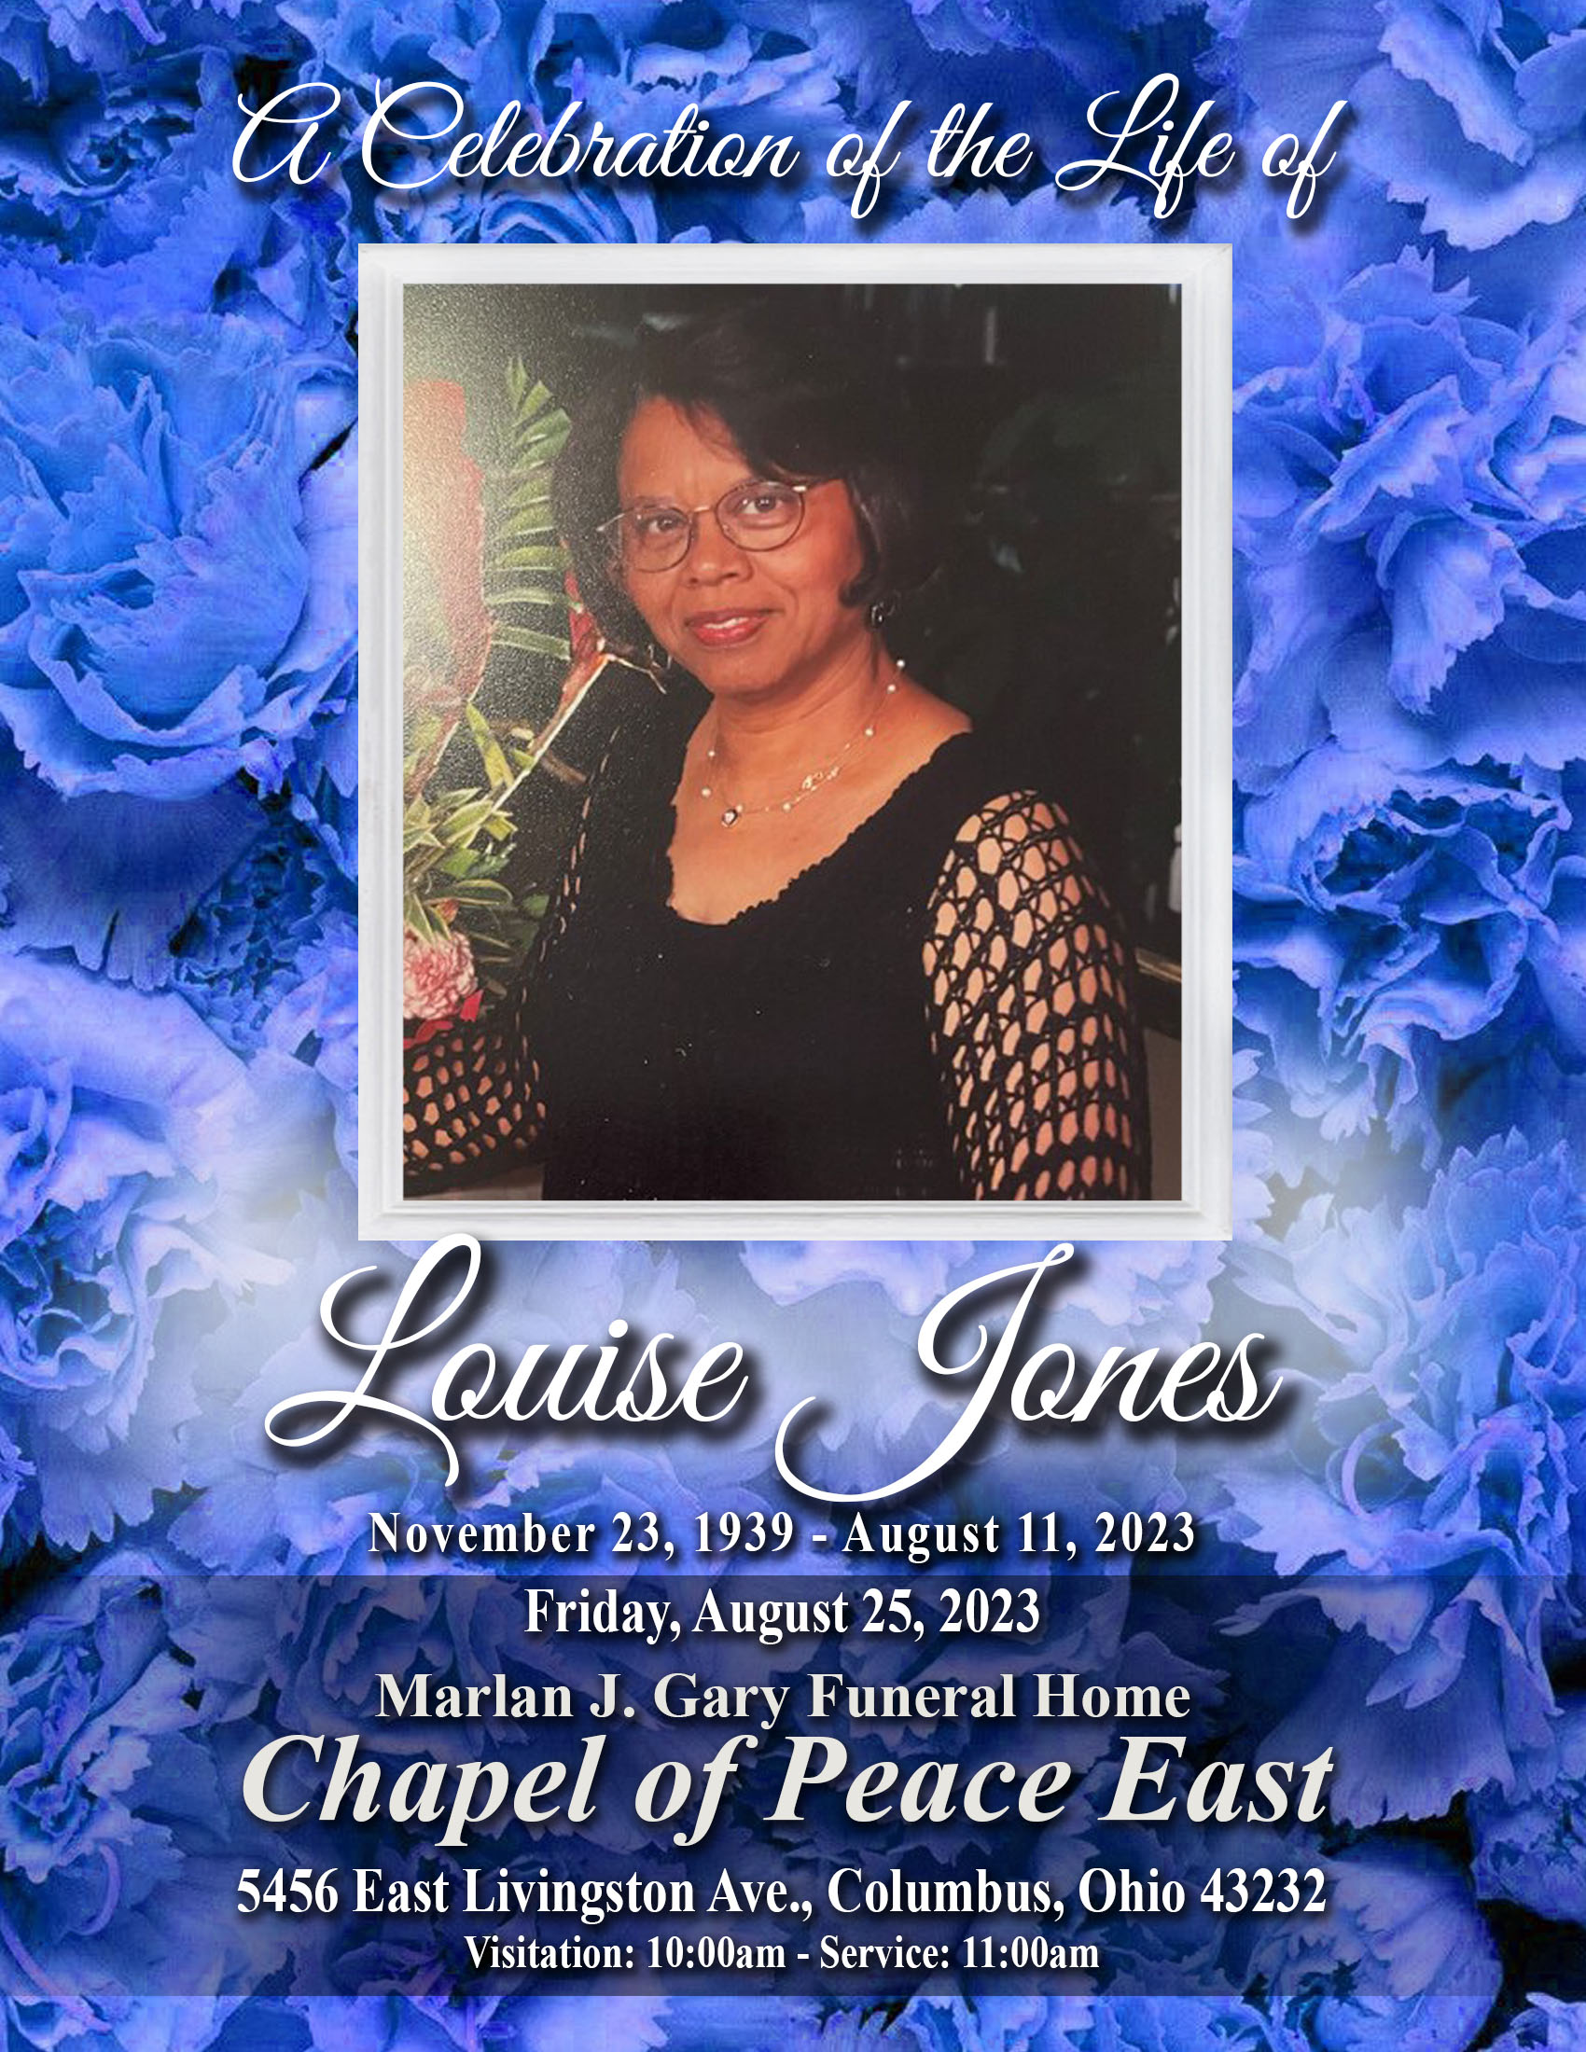
Expressions of Gratitude

The family of Louise Jones wishes to express our sincere gratitude for many acts of kindness, that has been shown to us during our time of bereavement. Your comforting prayers, cards, visits and phone calls; No acts have gone unnoticed and were a source of strength May God continue to richly bless you all! In lieu of flowers, memorial donations may be sent to the Alzheimer’s Association. https://www.alz.org

Pallbearers
Jason Holmes – Paul Holmes, Jr. – Desmond Reid
David Harriston – Rufus Bowers

Repast
Deb’s Celebration & Event Center
5508 East Livingston Ave.
Columbus, Ohio 43232

To offer condolences to The Jones Family,
visit www.TheChapelofPeace.com

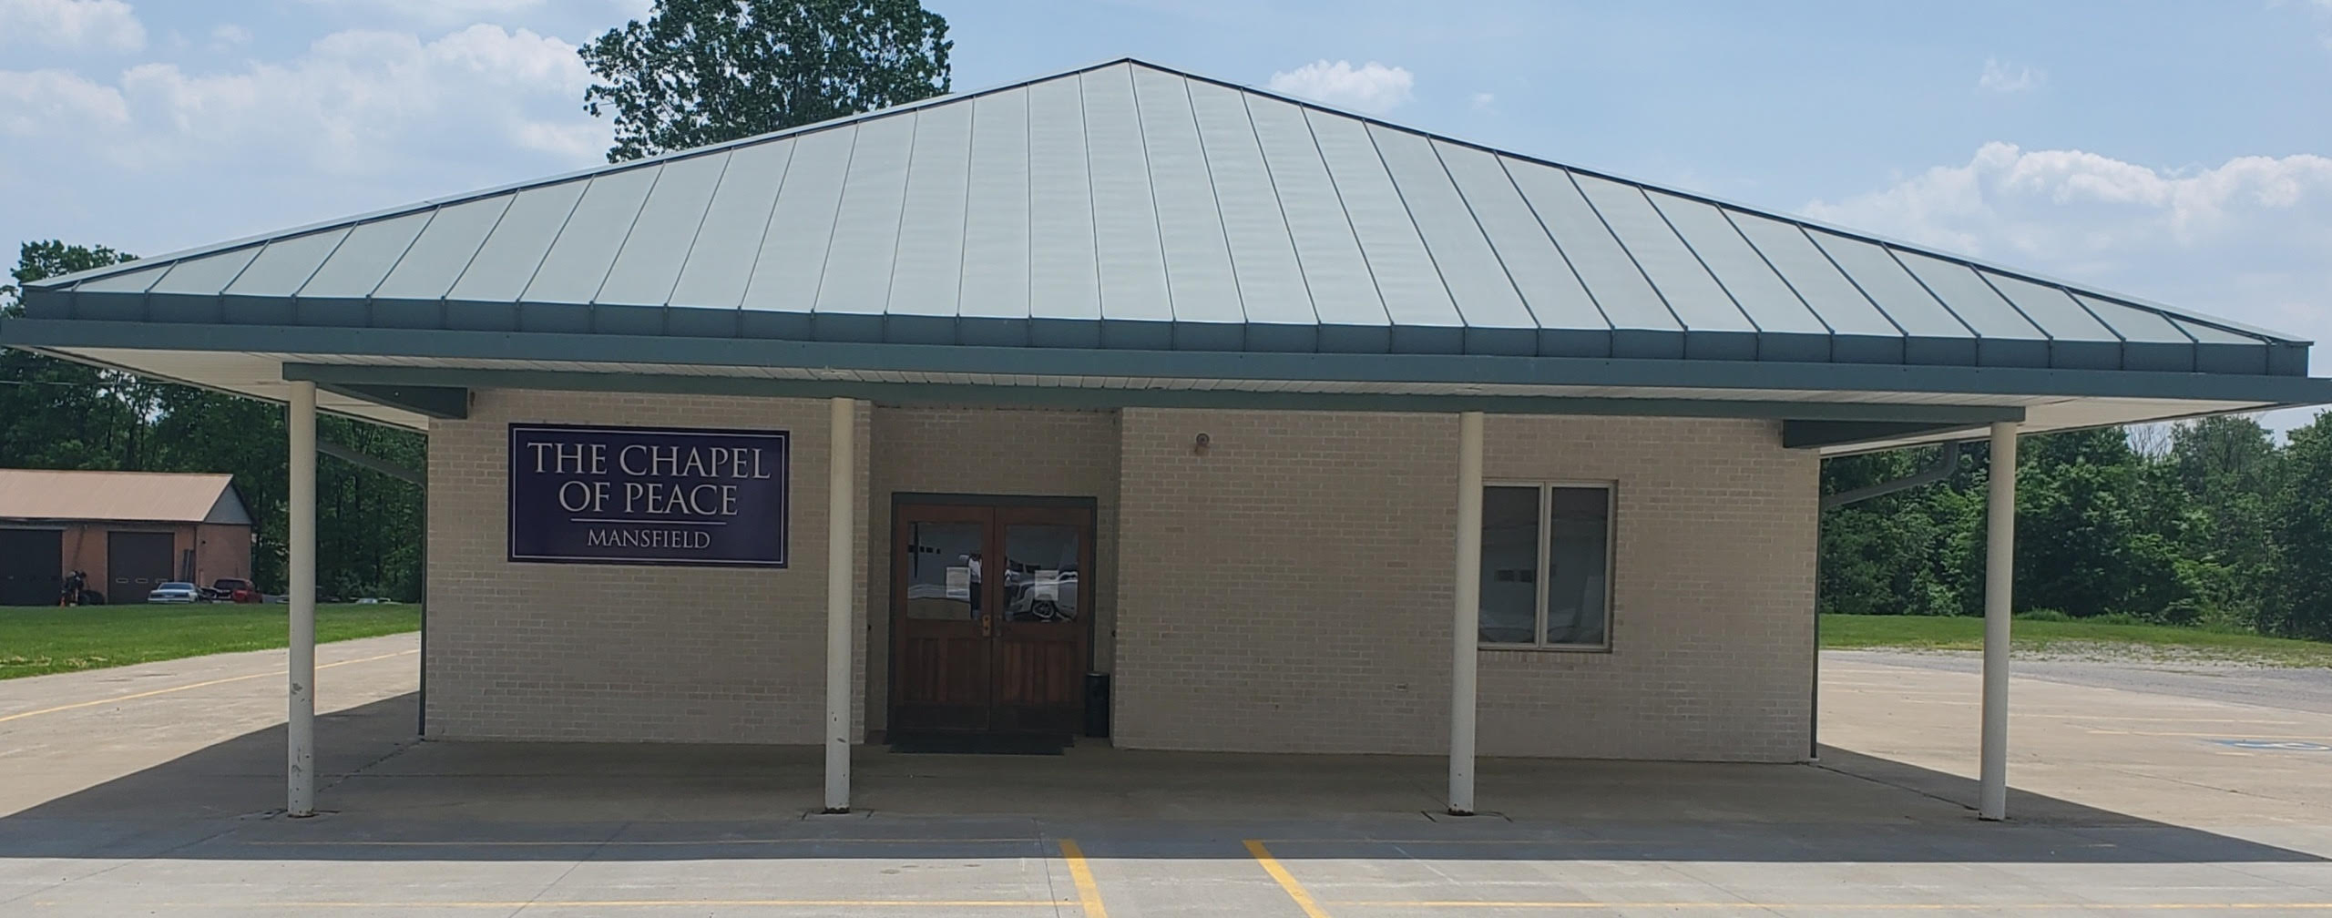

Obituary

Louise Jones, 83, of Columbus, Ohio passed away at home on August 11, 2023. Louise, fondly known as "Sister", was born in Boligee, Alabama on November 23,1939 to Willie J. Lockett and Mildred Plump. She was the third of seven children. Louise graduated from Dunbar High School in Bessemer, Alabama and went on to receive her associate degree from Lawson State University.

Louise accepted Christ at an early age. She was an active member of Southfield Community Missionary Baptist Church for over 50 years. Known for being a very quiet but active woman of God, she showed her love and devotion through actions and deeds. She faithfully served the church as a longtime member of the kitchen committee, becoming well known for her Banana Split cake. Southfield Community Missionary Baptist Church lovingly honored Louise with the Legacy Award in 2012.

Louise met Frank Jones Jr., her then next-door neighbor, as a young child. Louise and Frank would become married December 17, 1961, in Bessemer, Alabama. From this blessed union they built a beautiful family, raising their daughters Ursula Yvette and Valerie Denise.

Louise worked as a seamstress at Van Dyne Crotty for over twenty years before moving on to HFI Inc., where she would retire. However, Louise never gave up her love of sewing. As her hobby, Louise would stitch together clothing, furniture coverings and curtains. She even designed and sewed beautiful wedding dresses.

Louise was diagnosed with Dementia in 2017. As the disease progressed, she found comfort in spending time at home with her family. She enjoyed listening to music, playing word search games, planting flowers as well as vegetables. She also enjoyed feeding the birds that frequented her garden.
Her family faithfully took care of her and stood by her side every step of the way. They are sincerely grateful to the staff of VITAS Hospice Healthcare who assisted with Louise's care in her last stages.

Louise was a cherished wife, mother, sister, aunt and dear friend. She is survived by her devoted husband Frank; daughters, Ursula and Valerie; her siblings, Joe Graves, Matthew Bowers, Rufus Bowers, and Jacqueline Holmes (Paul); as well a host of nieces and nephews. Louise was predeceased by her parents Willie J. Lockett and Mildred Plump, her sister Willie Belle Lockett and brother Earl Bowers.

Order of Service

ORGAN PRELUDE Chapel of Peace Music Ministry

PARTING VIEW………………………………………Immediate Family

SCRIPTURE READING Clergy
Old Testament…………Psalms 23……. Pastor Alfred Mitchell
New Testament…John 14:1-6….…Pastor Tommy Jones, Jr.

PRAYER Pastor Alfred Mitchell

SELECTION……………..…………Chapel of Peace Music Ministry

ACKNOWLEDGEMENTS Chapel of Peace Staff

REMARKS Family and Friends

READING OF OBITUARY Read Silently

POEM…………………………………………………………Paul Holmes, Sr.

The Eulogy
Bishop Kenneth Moore

BENEDICTION Bishop Kenneth Moore

RECESSIONAL …………Clergy, Family, and Friends
Jeff Majors “Psalms 23”
Interment
Glen Rest Memorial Estate
8029 East Main Street
Reynoldsburg, Ohio 43068

