Acknowledgement

*The family of Darlene Wheeler is extremely grateful for all the kindness shown during this difficult time. Whether you sent a card, flowers, offered comforting words, lent a shoulder or just kept us in your thoughts, every deed of kindness was sincerely appreciated.*

Pallbearers

TERRENCE WILLIS SR. ~ MALIK WHEELER ~ JAMES MANNS

ANTHONY CUMMINGS ~ BARRELL GOLDEN ~ JAMIE WILDER

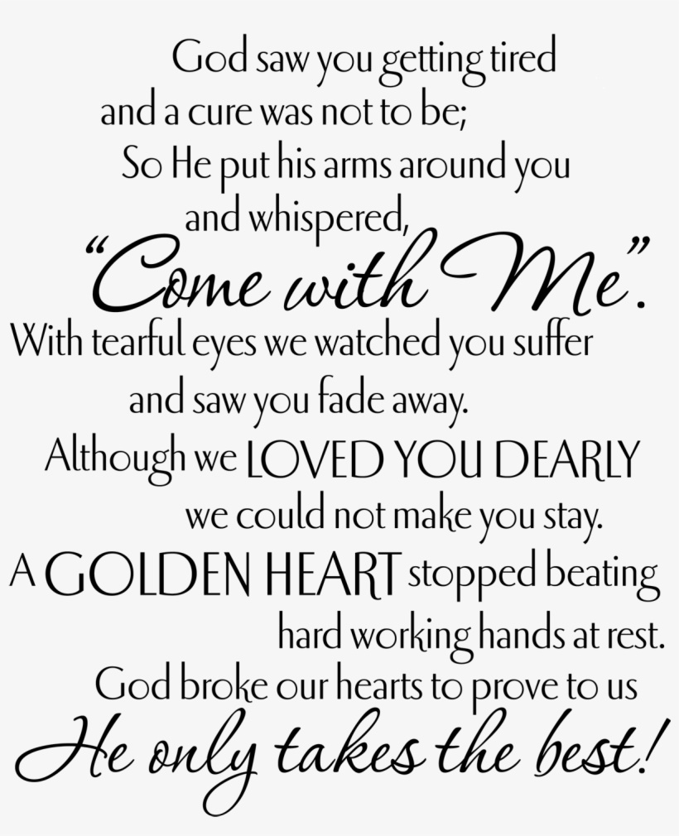

**

To offer condolences to The Wheeler Family,

visit [www.TheChapelofPeace.com](http://www.thechapelofpeace.com/)

**

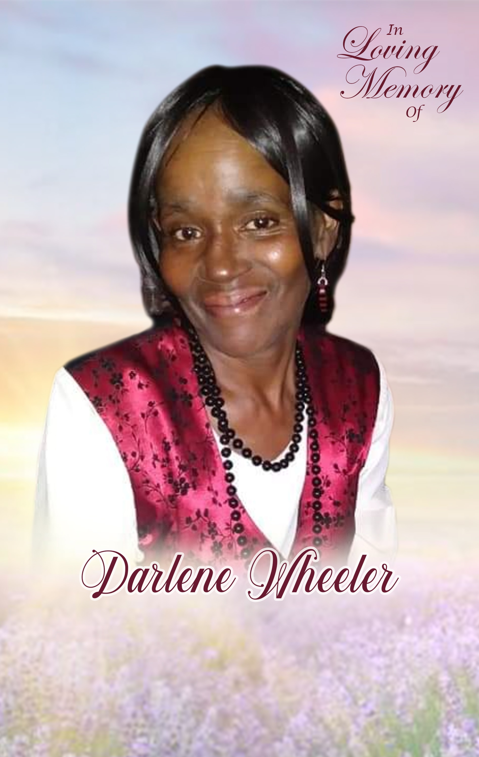

**FEBRUARY 4, 1954 ~ FEBRUARY 14, 2022**

**~Service~**

**TUESDAY, MARCH 1, 2022~ 11:00 AM**

**MARLAN J. GARY FUNERAL HOME**

***Chapel of Peace North***

2500 Cleveland Avenue │ Columbus, Ohio

Apostle Mary Crutcher, Eulogizing Minister

The Obituary

Darlene “Mimmie” Wheeler was born on February 4, 1954 to the parents of James Arthur Wheeler and Jattie Mae Duff. Darlene was the oldest of her twin sister Charlene by just a few seconds. She was the second to the youngest of seven girls.

Darlene attended Linden McKinley High School; she grew up on the north side of Columbus. Her mother made the girls attend Greater 11th Baptist church where she was introduced to Christ at an early age. Darlene recently attended services when she could at Kingdom Life Church where she found comfort in the ministry of Apostle Mary Crutcher. She attended the Break Every Chain conference and Aftercare program; she shared her wisdom in meetings and loved to attend the meetings. As a child Darlene enjoyed reading, and being around her twin sister Charlene, older sisters, and friends in the neighborhood.

Darlene worked for The Kroger Company for over 20 years she was known for her affectionate smile, quick wit and the Wheeler stare that would stop you dead in your tracks if you thought about doing wrong. Everyone knew Monday’s dinner menu: Pinto Beans, Cornbread and Fried Chicken wings! Darlene loved music Old School was her favorite and she was known for her Blue Monday Parties in which people in the neighborhood would come to the house to enjoy music, a good card game and Darlene chicken wings and fries. She kept her love of reading she has a vast variety of books in her library, she also enjoyed Backgammon (in which she cheated) card games and board games in which she loved playing Connect 4 with her great grandchildren. Darlene loved fashion and her love of jewelry has been passed down to her daughter, she would always have on a pair of unique earrings to match her ensemble.

Darlene presented herself a True Woman and she earned her respect by being an example of how woman should present herself. She kept her old school traditions; she was an example of what a true friend should be. If she did not like you, she did not hide it she did not believe in being fake to nobody. She was full of “jewels” in which she gave to her children and grandchildren in which will be greatly missed. When you asked her for advice she spoke with wisdom and truth, so you had to put on your Grown Women/Men pants because she was not going to sugar coat anything. These moments will also be missed.

Darlene is proceeded in death is her parents, James Arthur and Jattie Mae Wheeler; son, Edward Wheeler; sisters, Pauline Coles, Aletha “Susie” McCarthy, and Beatrice “Bea” Stabler; aunts, Tessie Hall, Lucille Marr, Mamie Mitchell, and Ella Duff; uncle, Paul E.I. Duff; grandparents, Reverend Walter C. and Christine Duff; niece, Melissa McCarthy; and nephews, Jeffrey McCarthy and Fred McCarthy.

Darlene leaves to cherish her sweet memories her only daughter, Mara Wheeler; only granddaughter, Marchae Wheeler; grandsons, Terrence Willis Sr, and Malik Wheeler; great grandchildren, Harmonee Young, Terrence Willis Jr, and Alaya Willis; twin sister, Charlene Wheeler; sisters, Ollie Mae Curtis and Bernadine McCarthy; and a host of cousins, nieces, nephews and friends.

[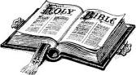](http://www.google.com/imgres?imgurl=http://www.bridalassociationofamerica.com/clipart/bibles/bible_09.gif&imgrefurl=http://www.bridalassociationofamerica.com/clipart/bibles/&h=808&w=1464&sz=38&tbnid=eYif1lnRBQy7gM:&tbnh=83&tbnw=150&prev=/images?q=bible+clip+art&hl=en&usg=__JZosKl3Dpg31s0Mdg2M4-TBXltg=&ei=egCgSuygGt6PmAeWlNn3DQ&sa=X&oi=image_result&resnum=2&ct=i)

Order of Service

PROCESSIONAL “Well Done”

by Deitrick Haddon

SCRIPTURE READING Kendra Stable

Old Testament Psalm 23

New Testament John 16:25-33

PRAYER Pastor Brenda Woodford

SELECTION Pajah Lindsay

ACKNOWLEDGEMENTS/CARDS Kenya Jordan

REMARKS Marchae Wheeler

Granddaughter

READING OF OBITUARY DeWayne McCree

READING OF DARLENE’S JEWELS Mara Wheeler

Daughter

The Eulogy

APOSTLE MARY CRUTCHER

King Life Church, Columbus, Ohio

BENEDICTION Apostle Mary Crutcher

RECESSIONAL

Interment

EVERGREEN BURIAL PARK

*I am the resurrection and the life: He that believeth in me*

*though he were dead yet shall he live.*

*And whosoever liveth and believeth in me shall never die.*

John 11:25-26